How To Report

Editable version

SpeakUp Introduction 2

How to leave a report 3

Via Web 3

Via the SpeakUp App 4

Written message 6

Voice message 8

Via Phone 10

SpeakUp Introduction

**SpeakUp®** is a service enabling you to report serious breaches that would otherwise not be reported, in complete anonymity. You can do this either via the website, by using the SpeakUp® app or by phone, without the interference of a human operator.

**SpeakUp®** is available **24** hours per day and **365** days a year. Therefore, you can use SpeakUp to leave a message or check for a response any time.

The service is operated by a third party, **SpeakUp**, an independent Dutch company based in Amsterdam, the Netherlands, and founded in 2004. **SpeakUp** is responsible for processing all messages.

How to leave a report

Via Web

1. Visit the SpeakUp webpage with the URL and/or QR code your organisation has communicated.
2. Click on ‘+ New report’ to start a trusted conversation.

In case you already have an open report, select ‘Log in’.

1. Click on “Web report”
2. Select the language in which you want to leave your message.
3. Note down your unique ‘Report number’ and create a password for your report.

You will need these to check back for a response later. This information is unique to you and

cannot be retrieve if lost. Please store it safely.

1. Type your message.

You can upload attachments via the clip icon found in the top-right corner.

1. Click ‘Send message’ and your message and attached files will be processed.
2. You have the option to leave your email if you’d like to be notified when there is a response.

After adding your email, you’ll be asked to type the verifying code sent to the provided email address.

Via the SpeakUp App

1. Download the ‘SpeakUp by People Intouch’ app from the App Store/Google Play or scan the QR code.

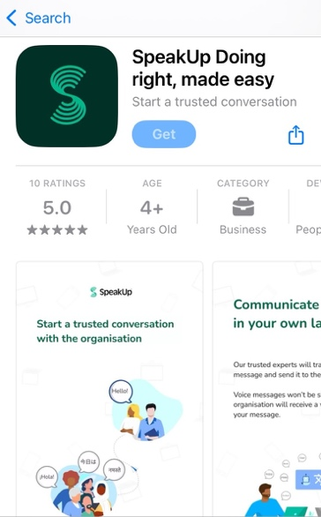

1. Open the App

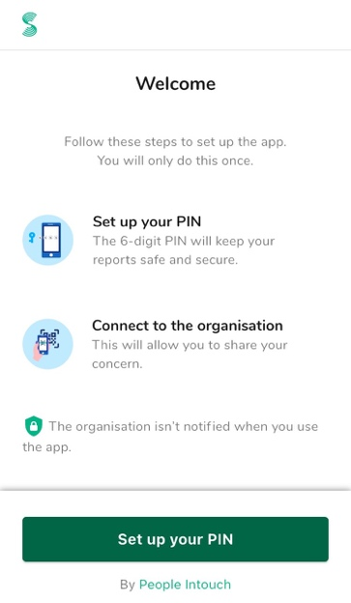

1. Click on ‘Set up your PIN’ and enter a 6 digit code.

* You will need to enter this PIN each time you open the App.

If you forget your PIN, you need to re-install the App and set up a new one. If so, you will lose access to your ongoing open reports.

1. You can connect to your organisation by scaning the QR code. Alternatively you can enter the Organisation code by clicking on ‘Connect Manually’ on the bottom of the page.

* The QR and/or the Organisation code has been communicated to you by the organisation.

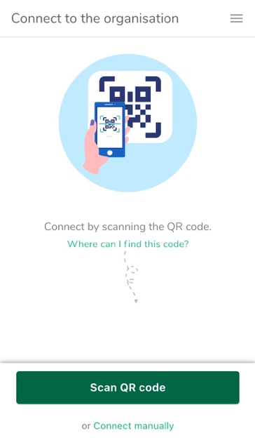

1. Press the ‘+ New report’ button to start a trusted conversation.

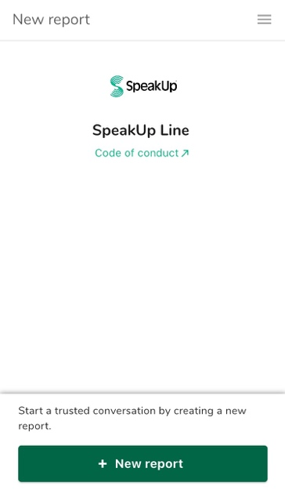

1. Select the type of report you want to leave

1. If you select to leave a misconduct report, you can leave a written message or record a voice message, if your organisation has enabled it:

* **Written message**

1. Click on “Write a message”

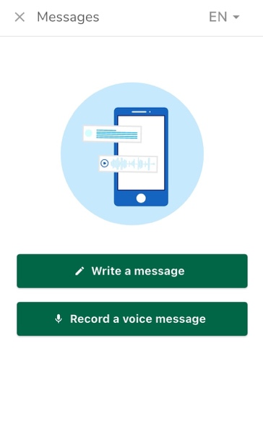

1. After typing your message, press the arrow icon to send it. You may attach files (up to 25 items) by clicking on the paper click icon.

1. After sending your message you can expect a reply within one week. You can opt to be notified by the app of any responses.

1. When you log back in you will see if there are any new responses from the organisation.

* If you have a different concern to report, you can do so by clicking ‘+New report’.

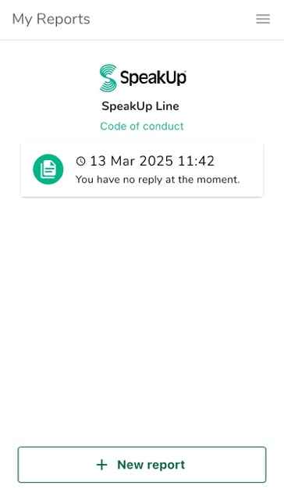

* **Voice message (If offered by your organisation)**

1. Click on “Record a voice message”



1. Press the record button to start speaking. When you're finished, click the stop button.
2. You will see the transcript of your message and will have two options:

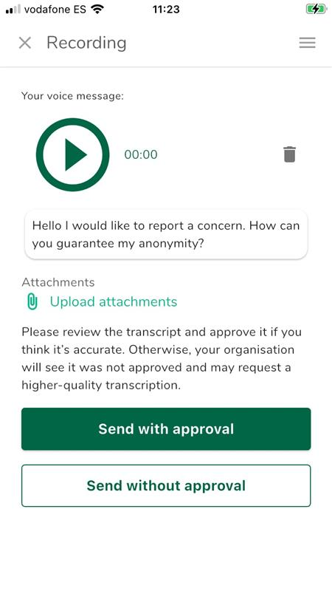

* **‘Send with approval’**: If you are satisfied with the transcript of your message.
* ‘**Send without approval’**: You organisation may request a higher-quality transcription. You can also click on the trash icon next to the recording and record the message again.

1. After sending your message you can expect a reply within one week.

* You can opt to be notified by the app of any responses.

1. When you log back in you will see if there are any new responses from the organisation.

* If you have a different concern to report, you can do so by clicking ‘+New report’.

Via Phone

1. Your organisation has communicated the SpeakUp phone number relevant to your location.
2. Dial the phone number for the country that you are located in.
3. The voice prompts will guide you through the following steps:
   1. Enter the ‘Organisation code’ shared by the organisation with you.
   2. Select your language.
   3. You will receive a unique ‘Report number’.

* Write this down carefully as you will need it to be able to call back and hear a response to your report.
  1. Choose a 4 digit PIN code.
* Remember it so that you can log back in later.
  1. You will be informed that you will be recorded, and a written copy will be shared with your organisation. Your recording will not be shared with your organisation.
  2. After the tone simply speak your message.
  3. Once done, press 1 or simply hang-up.
  4. You can expect a response within one week. Make sure to call back with your Report number and PIN to check for a response.

Olympisch Stadion 6, 1076 DE www.speakup.com